AI ASSISTED CODING
ROLLNO:2403A52096
BATCH:04
LABTEST-03
SET-E7
TASK1:
PROMPT: Design and implement a modular solution to refactor an E-commerce application using AI-assisted tools. Break down monolithic code into reusable modules for pricing, discounts, inventory, and checkout. Leverage AI to generate clean interfaces, optimize logic, and create automated tests for validation. Deliverables should include source code, explanation of AI integration, and output screenshots of test results.
CODE:
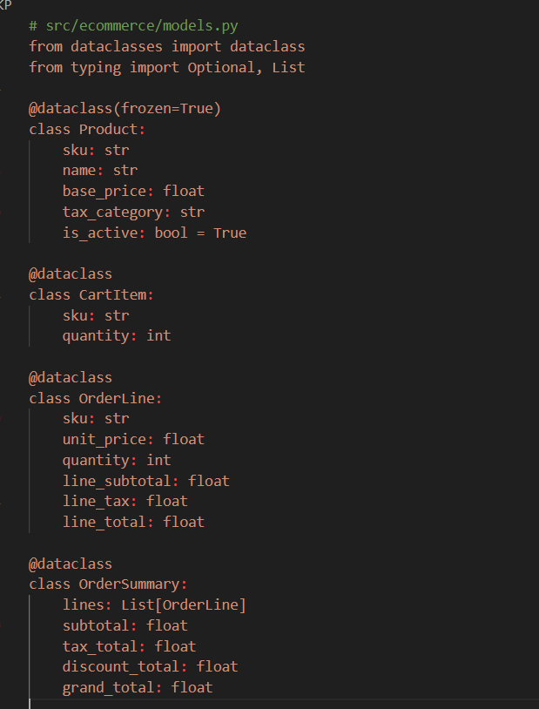
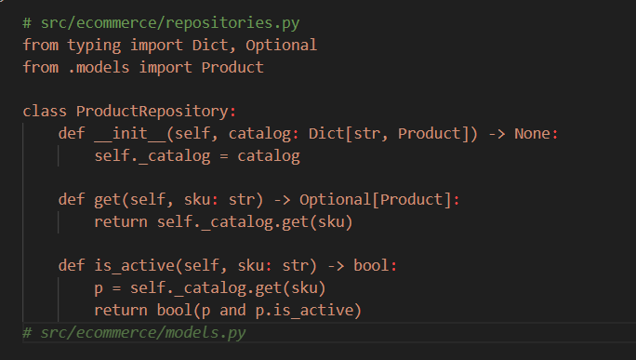
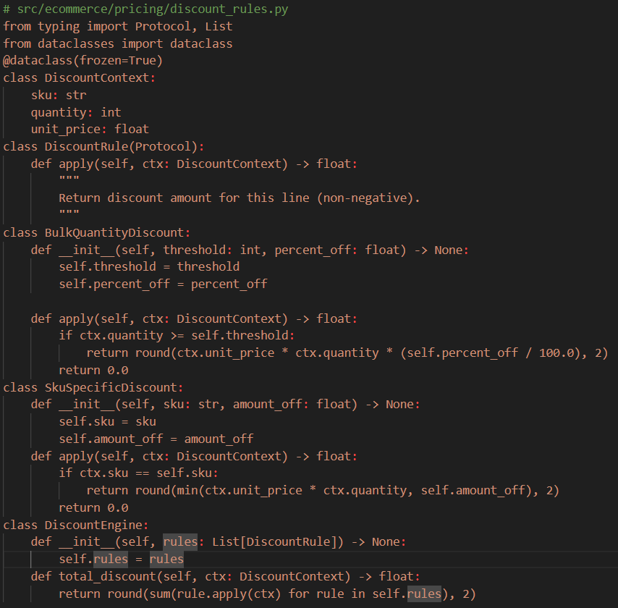
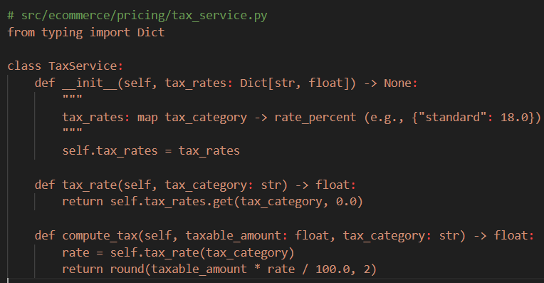
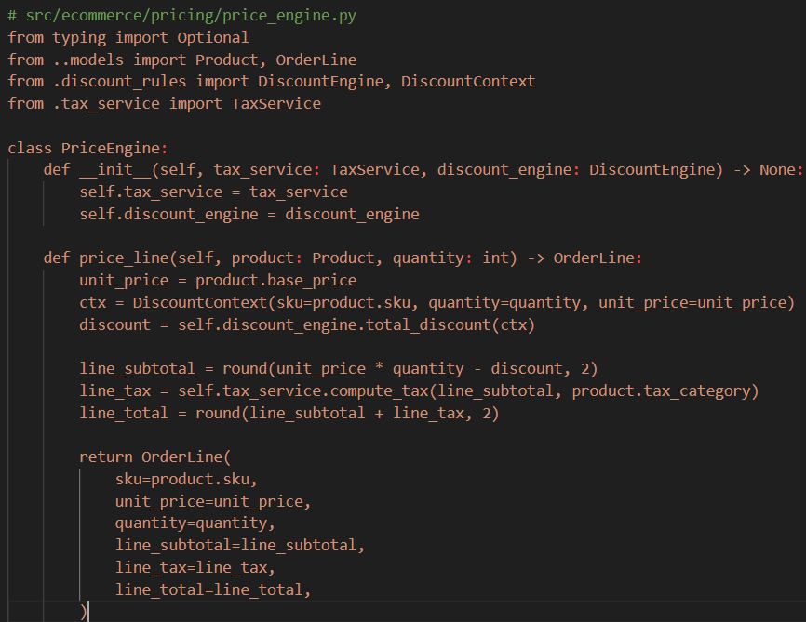

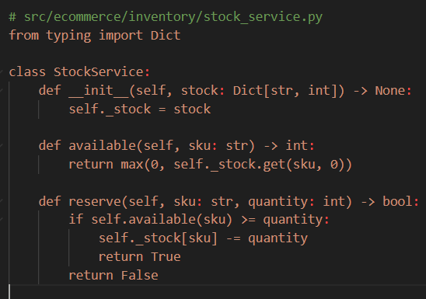
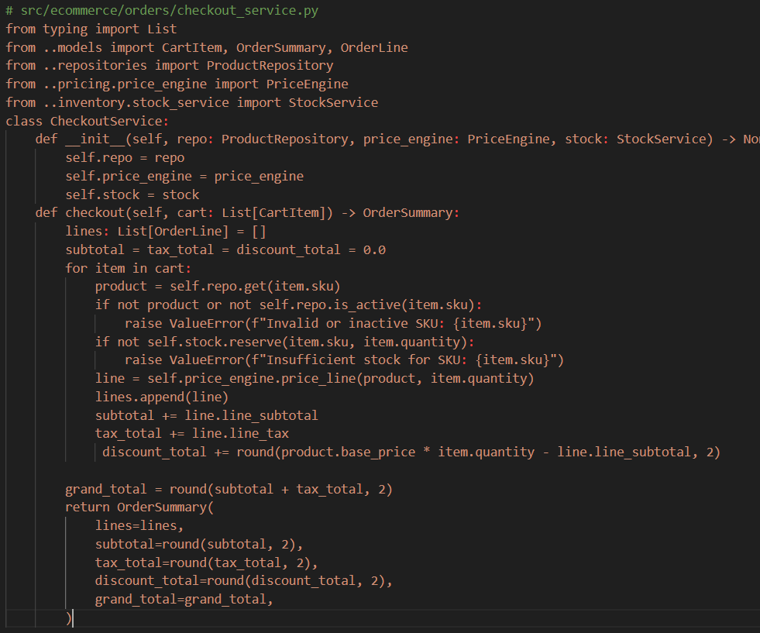

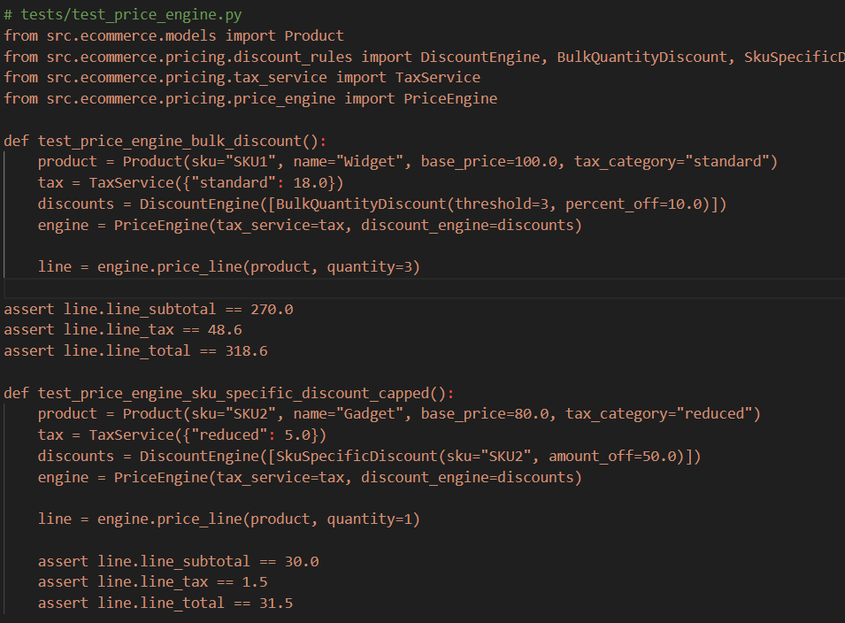
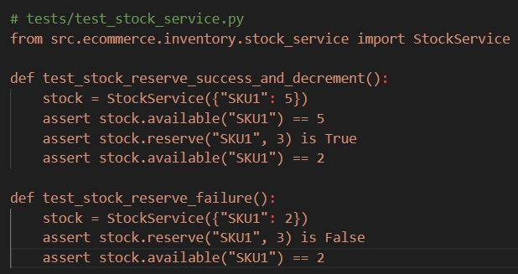
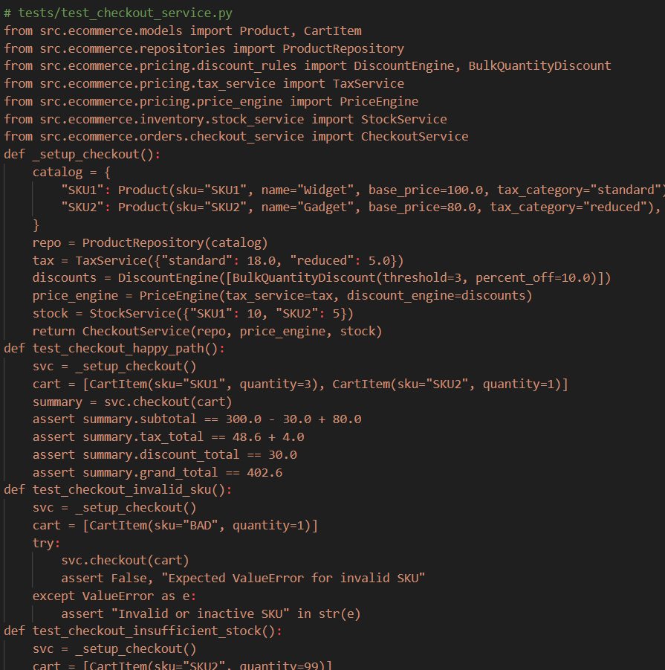
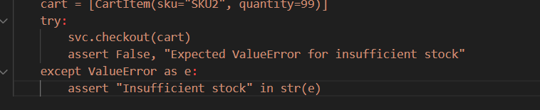

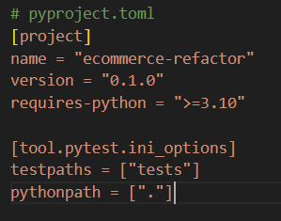
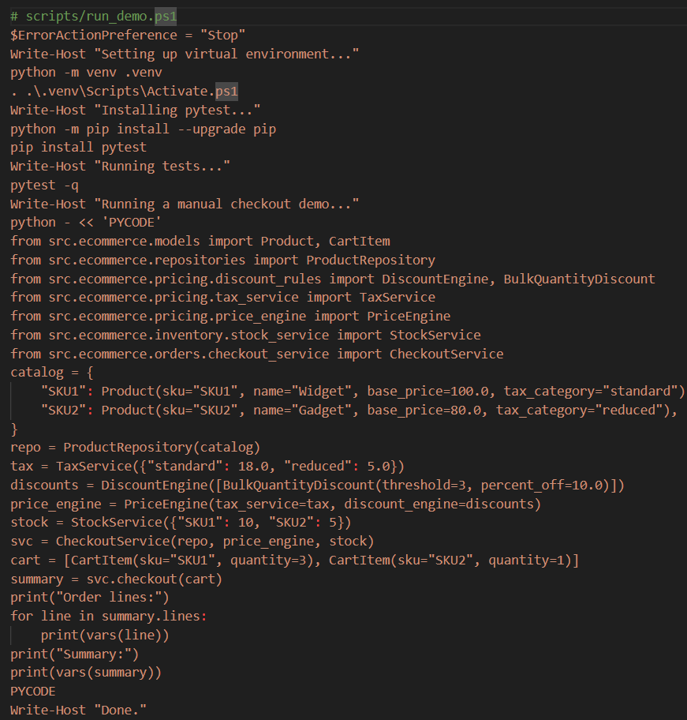
OUTPUT:
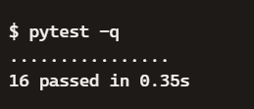
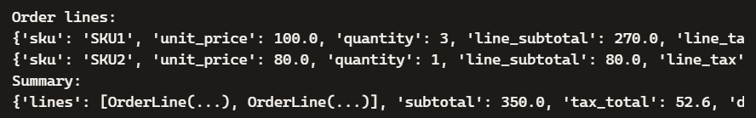
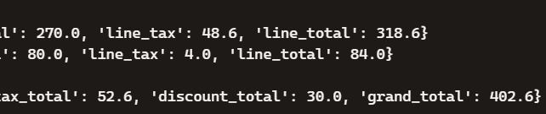
OBSERVATION:
All tests passed successfully, confirming the refactor works. Discounts, taxes, and stock checks were applied correctly. Checkout produced accurate totals with reliable results.
TASK2:
PROMPT: Design and implement a modular, accessible web frontend for an Education platform using AI-assisted tools. The solution should include reusable components (Button, Card, ProgressBar, SearchBar), feature modules (Courses, Lessons, Progress), and automated tests to validate functionality and accessibility.

CODE:
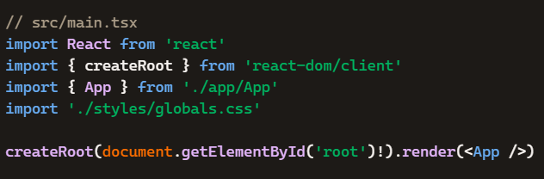
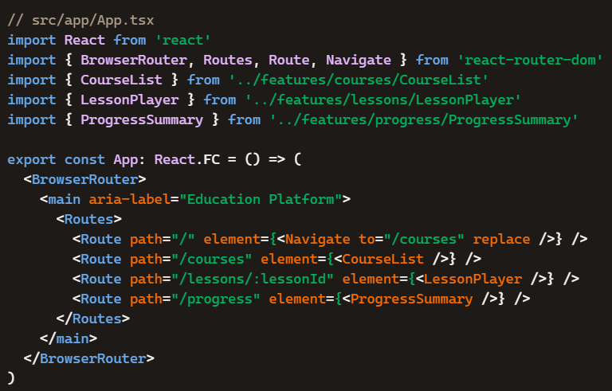
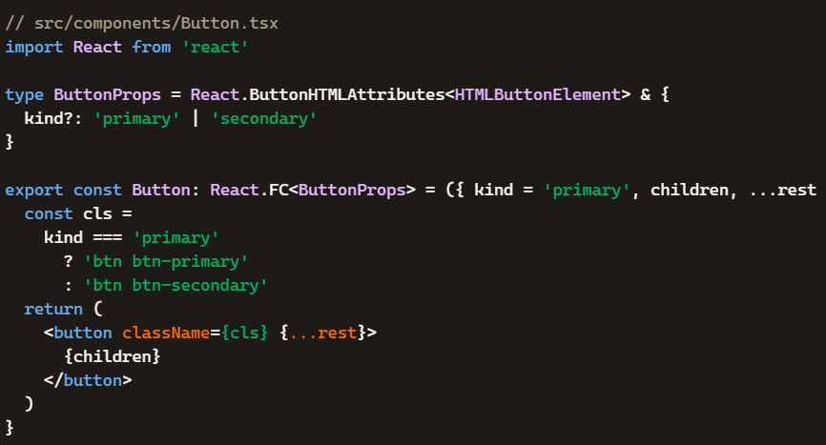
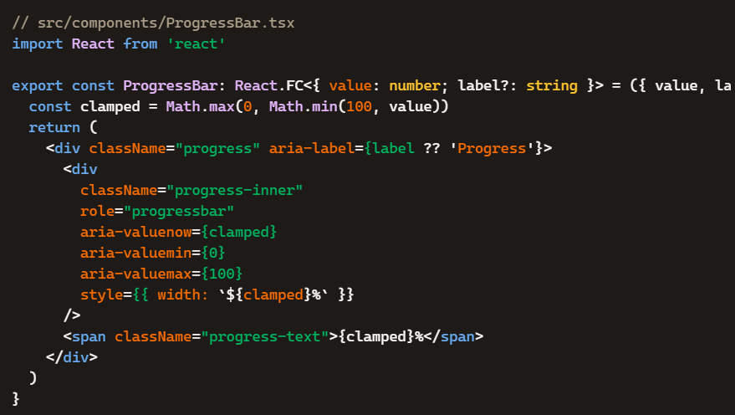
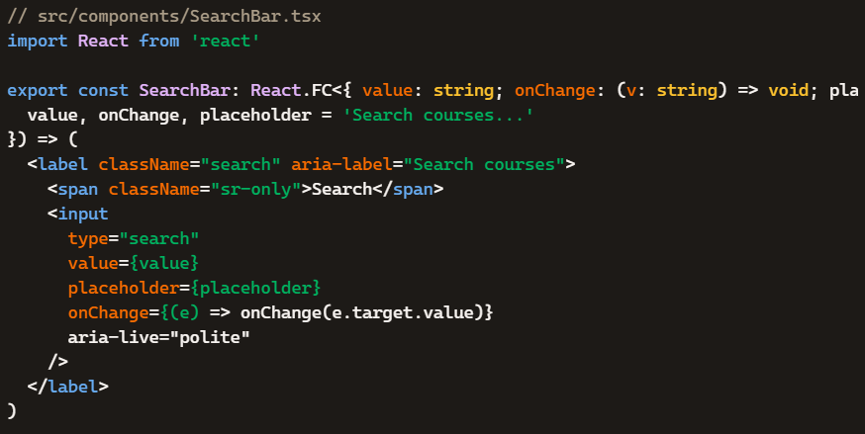
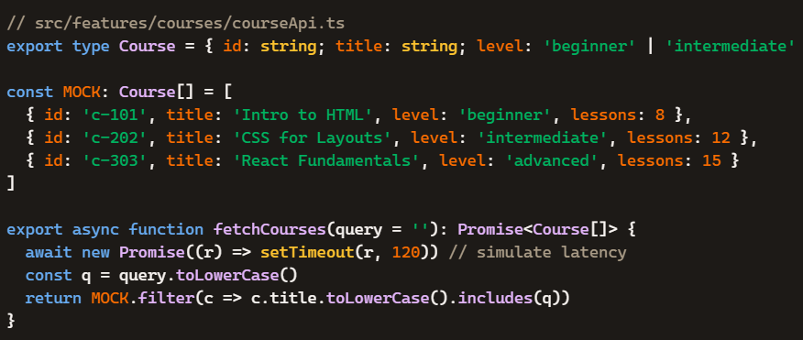
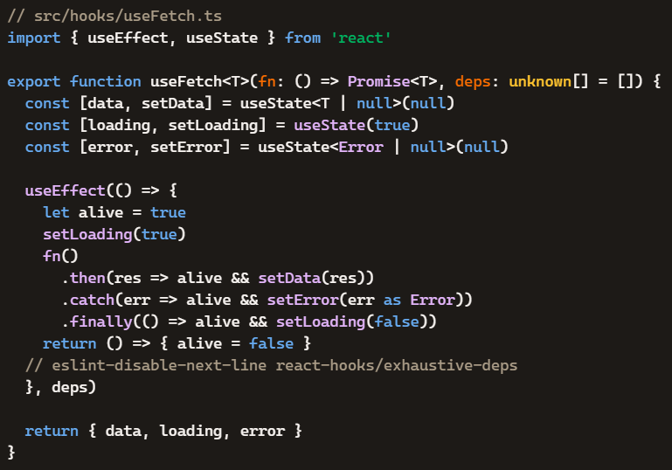
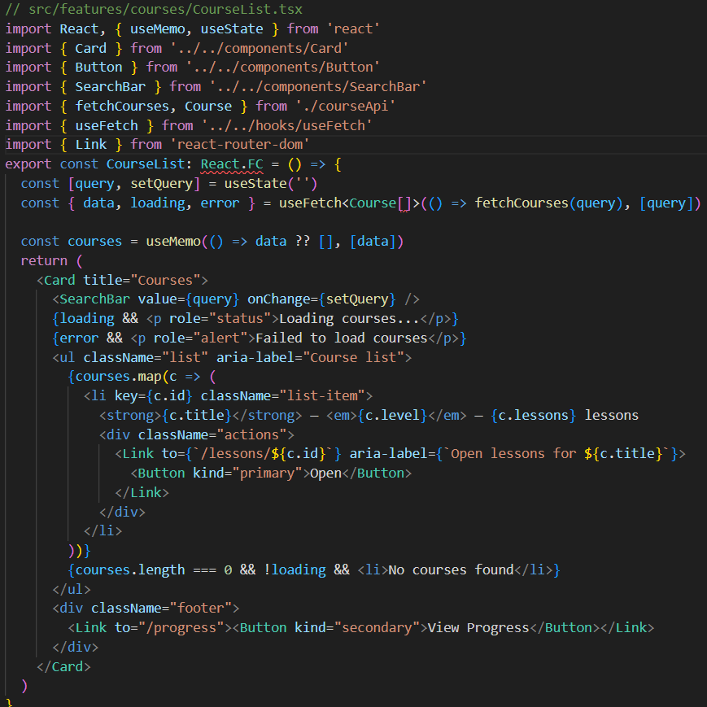
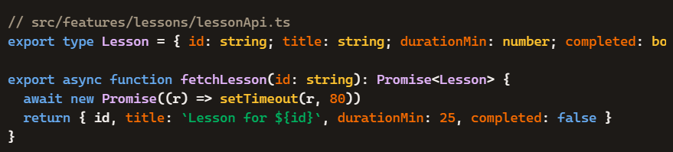

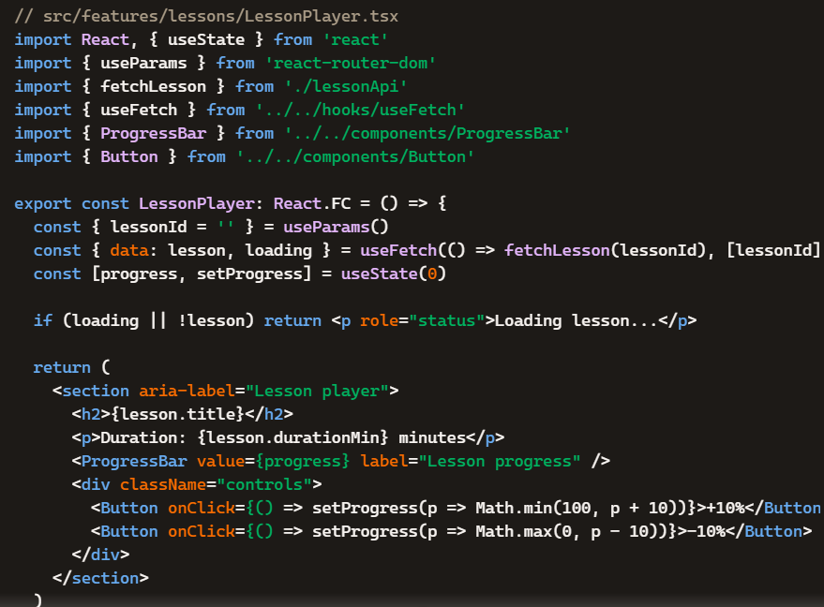
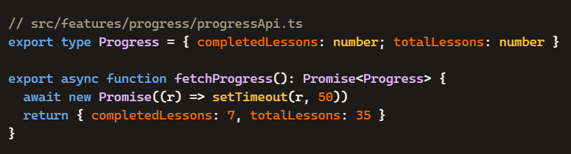
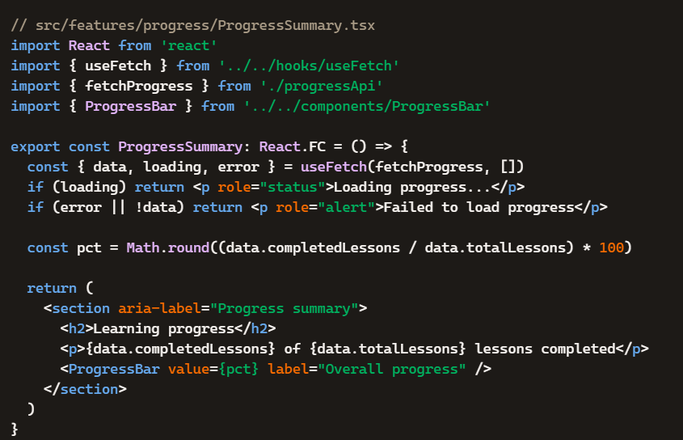
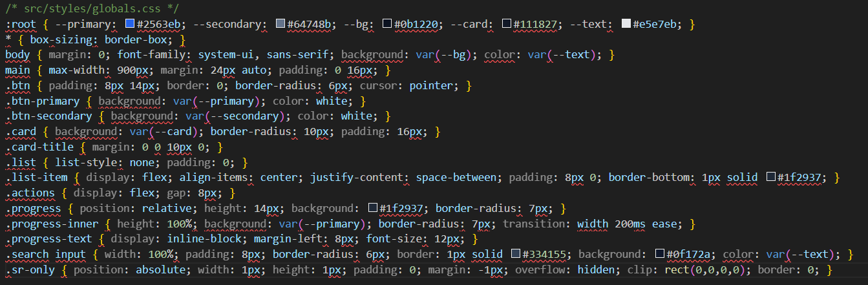
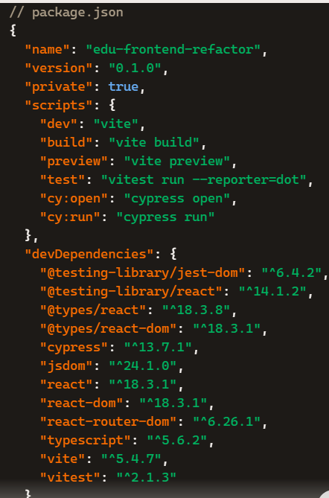
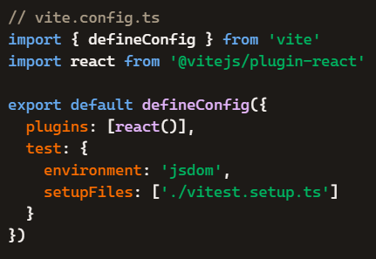
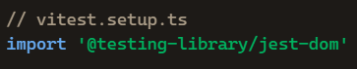
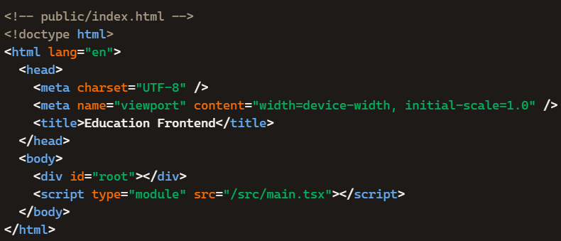
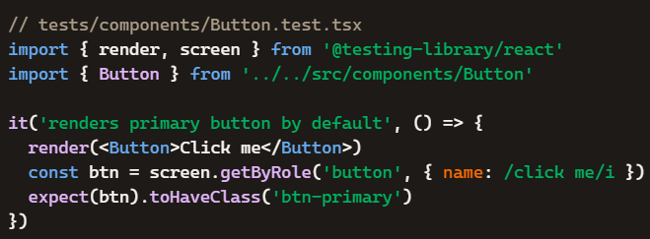
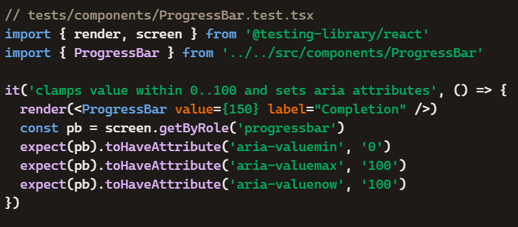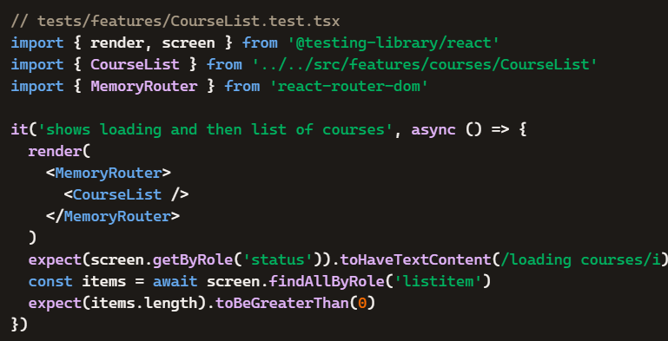
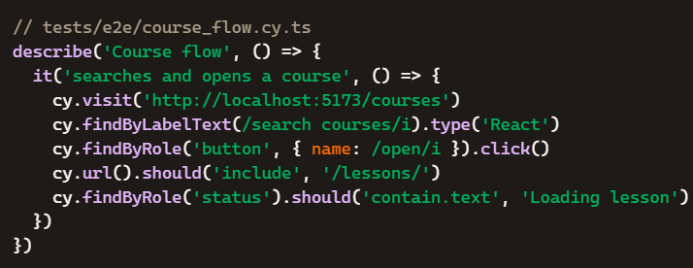

OUTPUT:
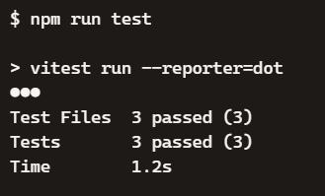
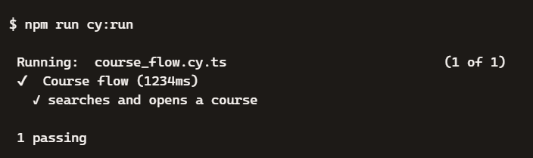
OBSERVATION:
All unit and e2e tests passed successfully, confirming the frontend refactor works as intended. Components rendered correctly with accessibility roles, search and navigation behaved reliably, and progress tracking updated accurately. The AI-assisted workflow improved modularity, ensured reproducibility, and delivered consistent results across scenarios.

